The Advantzware Box Management system can be run from the main menu or separate Icons may be used to run specific applications. The screen shot of the desktop below shows a few popular menu options that have been converted into Icons. The benefit is the users of the icons will not see any other options, hence this also provides security.

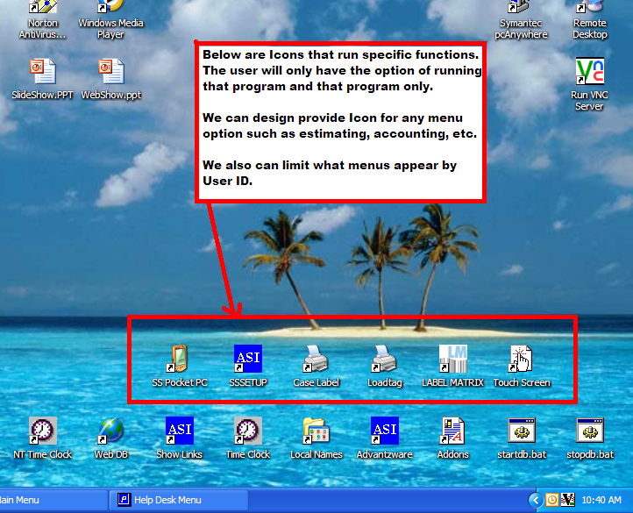

If I click the Load tag Icon above, the only menu is shown below.
This allows a production person that only prints load tags with one click.
He can enter a range of orders or items plus has options what will print.
Even the options are remembered so he need not think.

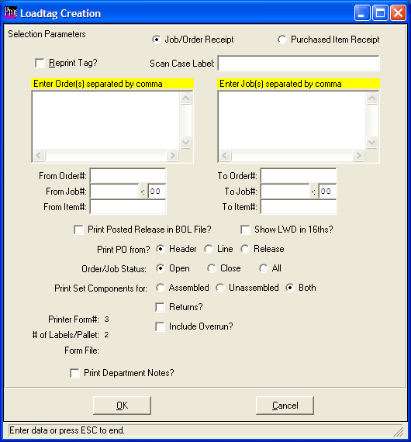

If I were to click the Touch Screen Icon above, the following would appear.
Therefore, production personnel only have access to login and adding
machine hours by job. The reporting menus and file maintenance menus
are not displayed, hence adding security and user friendliness.
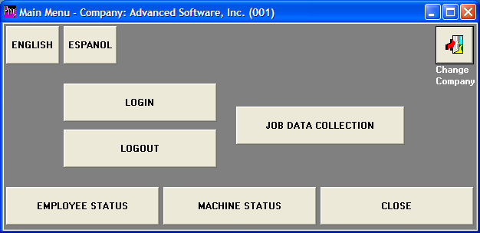

If I were to click the Sharp Shooter Icon above, the following would appear.
This menu was designed for the handhelp pocket PC device, thus the screens are sized to the smaller screen size of the pocket PC.
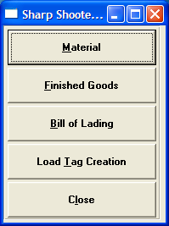

Advantzware can also provide limited menu options by user.
As you see, I have selected the user name JOEY and I can simply remove any menu option. When JOEY logs in, the deleted menus will not appear.
It is more friendly and more secure. Of course we also have security to view screens, but limit addition, deletion and updating.

